**Homework 02**

**Team Members:**

|  |  |  |
| --- | --- | --- |
| Name | SJSU ID | Github link |
| Himangini Agrawal | 012491349 | **https://github.com/HimanginiAgrawal/JENTAB** |
| Mudrita Chaturvedi | 012418094 |  |
| Abhi Yelipeddi | 012471472 |  |
| Avleen Singh Khanuja | 012409904 |  |

**Abstract:**

This application is designed to integrate twitter APIs and use data received from its APIs to perform various processes such as using search API to decide what is trending on twitter based on the number of records retrieved for given search key or using timeline API to decide the most discussed topics among followers. The application allows data consumption based on polling or some on occurrence of some event. It also allows data to be posted to Twitter after authorizing user using the access key and token. The application leverages twitter components provided by Twitter4J for easy integration to APIs. For deployment, we are creating WAR using maven build and deploying the WAR from Maven repository to Karaf OSGI container.

**Architecture diagram:**

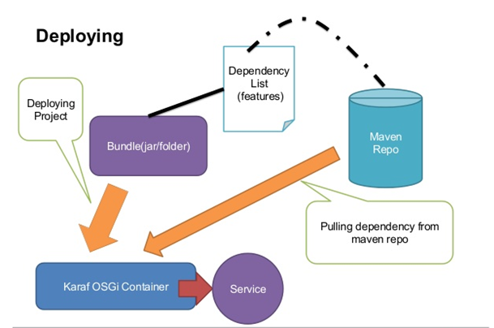

**Routing Explanation:**



**Patterns used:**

**APIs used:**

1. Twitter Search
2. Twitter Timeline/home
3. Twitter Direct Messages
4. Twitter Friends and Followers
5. Twitter Users
6. Twitter Lists
7. Twitter Trends
8. Twitter Tweets

**Use Case diagram:**

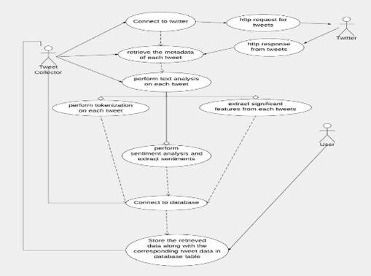

**Use cases:**

* **Use case 1:** First API that we have implemented is Twitter Search. Using this API, we can search for tweets based on a search key. This can be used to find the trending topics on twitter. The key that returns the most number of results can be the trending topic at the given time. Similarly, we can also determine popularity of any topic. If the search key does not return good amount of data, it may not be popular at given time.
* **Test case:**
* Test case 1: Search for a key “Trump”
* Expected Result: The tweets related to search key should be displayed on UI and logged in Karaf logs.
* Actual Result: The tweets related to search key displayed on UI and got logged in Karaf logs.
* **Result screenshots:**

*Results on browser*



*Results in logs*

**

* **Use case 2:** SecondAPI that we have implemented is Timeline/home. The message returned from this API can be used to determine what topics are getting tweeted by Users that are followed by a particular user. This data can be used to determine trending tweets that are being posted by users that a particular user is following.
* **Test case:**
* **Result:**
* **Use case 3:**
* **Test case:**
* **Result:**
* **Use case 4:**
* **Test case:**
* **Result:**
* **Use case 5:**
* **Test case:**
* **Result:**
* **Use case 6:**
* **Test case:**
* **Result:**
* **Use case 7:**
* **Test case:**
* **Result:**
* **Use case 8:**
* **Test case:**
* **Result:**

**Source Code:**

Source code for application is present on github.

Location: https://github.com/HimanginiAgrawal/JENTAB